

*AI 407 – Introduction to Robotics*

**Lab 3 Manual**

**ROS 2 Workspace, Packages, and node**

* **Lab objectives**
* **Learn about ROS2 workspaces, packages, and nodes**
* **Lab Requirements**
* **Software:** Ubuntu 22.04 LTS, ROS 2 Humble
* **Hardware:** Students should work on Lab Devices
* **Before You Start**

Kindly read the slides, review the references if any, before beginning implementation.

* **Exercise 1:**

Create a workspace with your name and clone the following repository in it using the command:

git clone https://github.com/ros2/examples src/examples -b humble

**Put screenshots of your work here:**

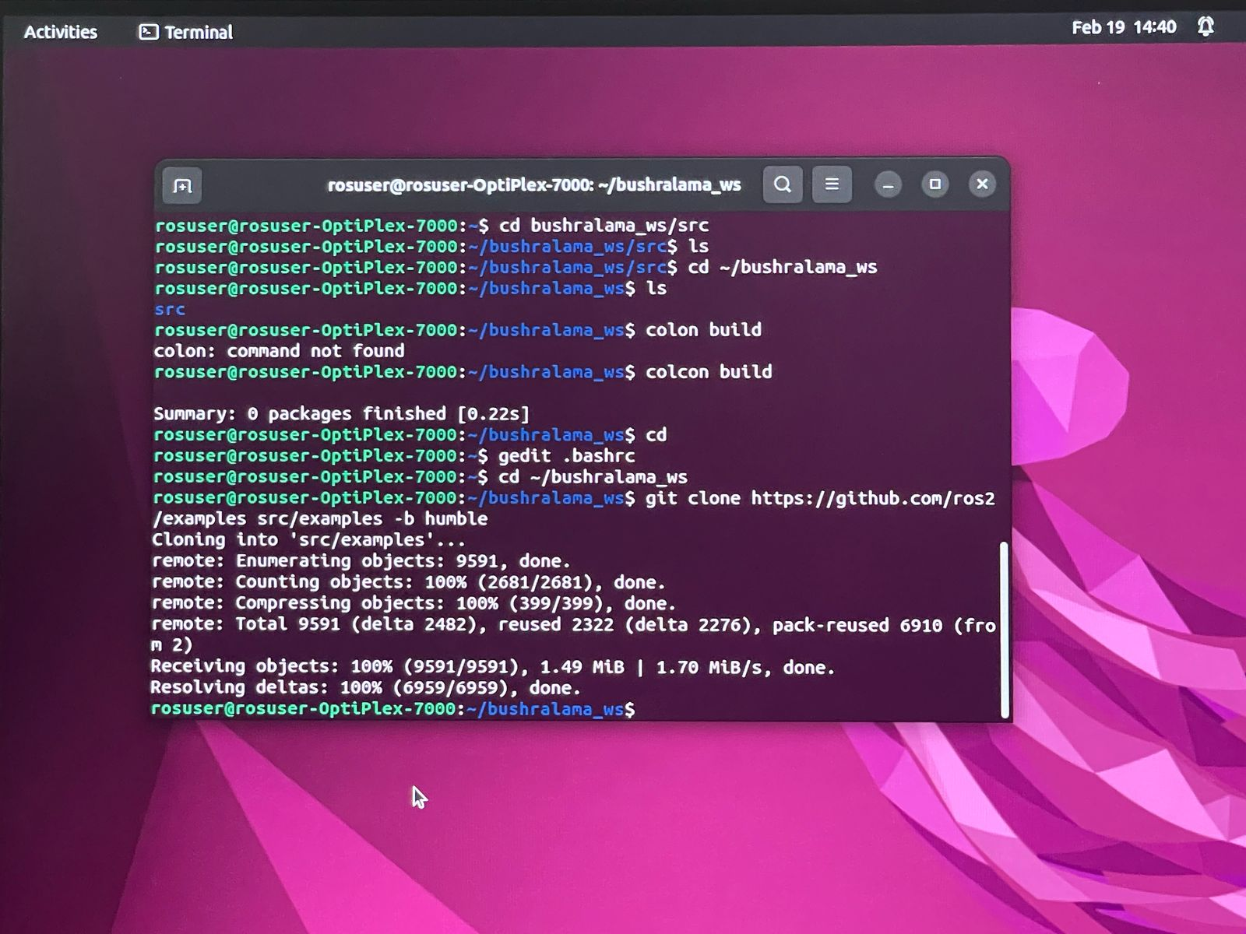

**_________________________________________________________________________________**

* **Exercise 2:**

The Hello World Example Using ROS 2 (Create package + nodes)

1. Creating a hello_world Package to send and receive a “Hello World” string message.
2. Creating Python Nodes (publisher node and subscriber node)
3. Executing Python Nodes
4. Visualizing a Computing Graph

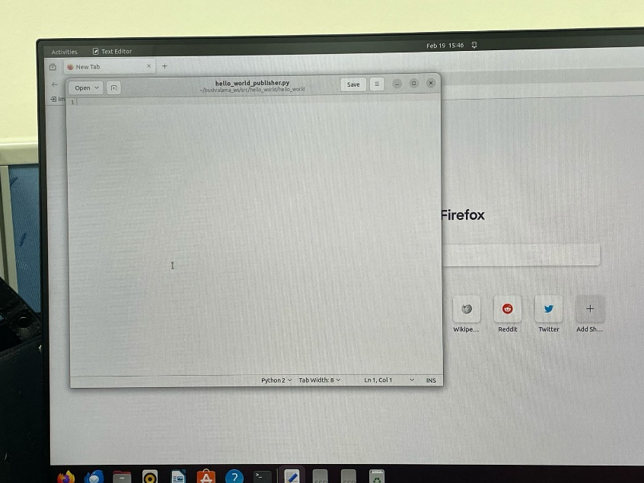**Put screenshots of your work here:**

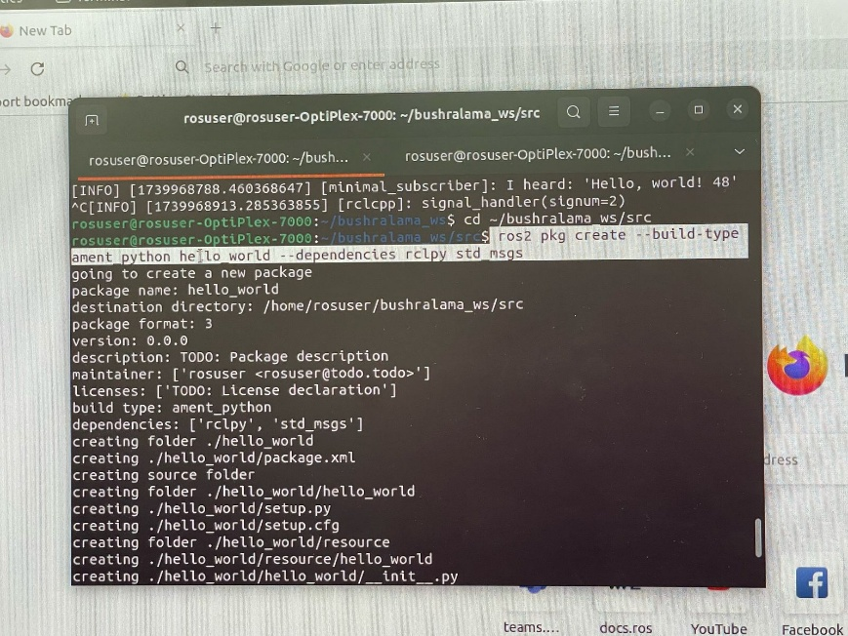

*صورة تحتوي على نص, الإلكترونيات, لقطة شاشة, الحاسوب

قد يكون المحتوى المعد بواسطة الذكاء الاصطناعي غير صحيح.*

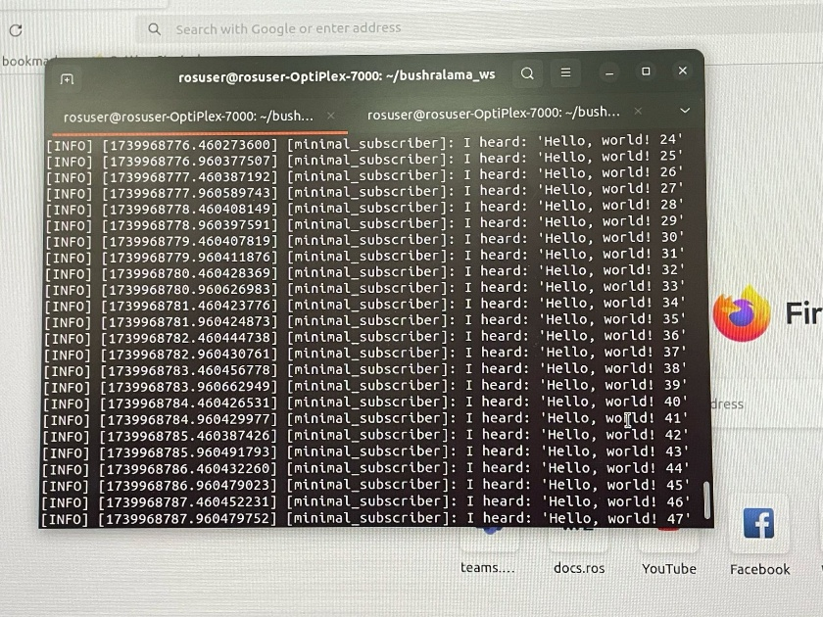

**_________________________________________________________________________________**

**References**

[**Ubuntu (deb packages) — ROS 2 Documentation: Humble documentation**](https://docs.ros.org/en/humble/Installation/Ubuntu-Install-Debs.html)

[**Documentation - ROS Wiki**](https://wiki.ros.org/)